**Unminify picoCTF**

**Category — Web Exploitation**

**Level — Easy**

**Challenge URL — [picoCTF — picoGym Challenges](https://play.picoctf.org/practice/challenge/426?category=1&difficulty=1&page=1" \t "_blank)**

*Welcome! It is time to look at the Challenge “***Unminify***” on picoCTF. I am making these walkthroughs to keep myself motivated to learn cyber security and ensure that I remember the knowledge gained by playing picoCTF Challenges.*

*Join me on learning cyber security. I will try and explain concepts as I go, to differentiate myself from other walkthroughs.*

**About Challenge —***The challenge is an easy Web Exploitation challenge. Let’s start!*

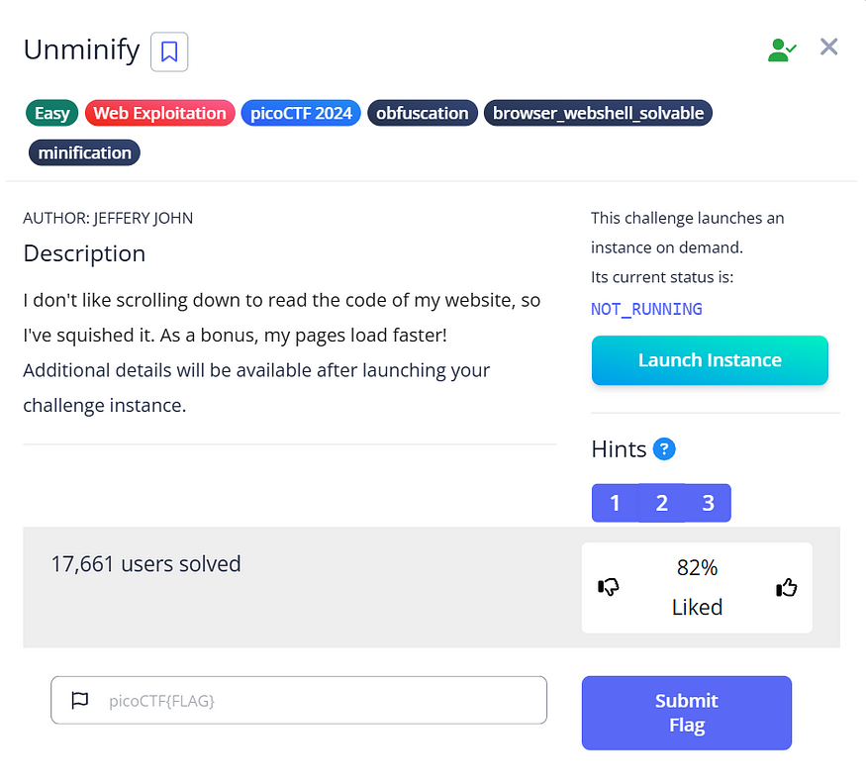

**Unminify**

*Let’s start! Launch Instance.*

*The website for the challenge.*

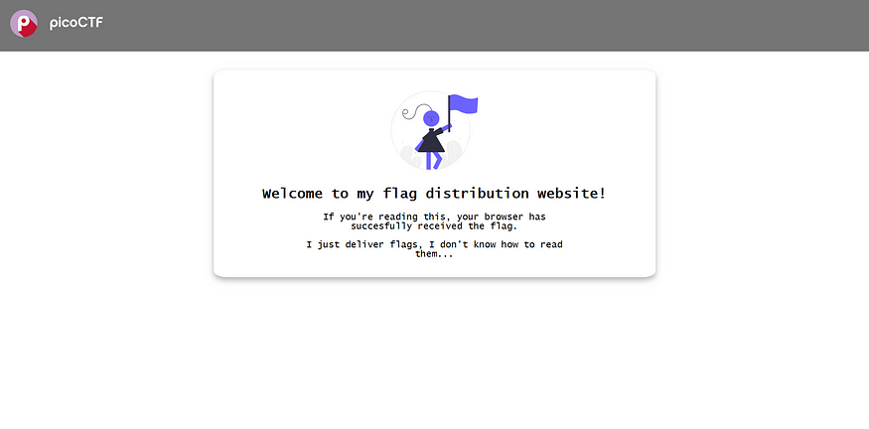

***The website for the challenge.***

*I know that the challenge involves using inspect tab. This means that it is likely that we are supposed to find the flag hidden in the code of the website. Thus, I used the search tool on the website and searched for the flag.*

***See the contents of the page.***

http://titan.picoctf.net:53517/

*First, let’s try viewing the page source of the website that opened by pressing****CTRL+U****.*

*After reviewing the code, it appears that the flag is hidden there.*

***Ok! We found The FLAG in view-source.***

<!doctype html><html lang="en"><head><meta charset="utf-8"><meta name="viewport" content="width=device-width,initial-scale=1"><title>picoCTF - picoGym | Unminify Challenge</title><link rel="icon" type="image/png" sizes="32x32" href="/favicon-32x32.png"><style>body{font-family:"Lucida Console",Monaco,monospace}h1,p{color:#000}</style></head><body class="picoctf{}" style="margin:0"><div class="picoctf{}" style="margin:0;padding:0;background-color:#757575;display:auto;height:40%"><a class="picoctf{}" href="/"><img src="picoctf-logo-horizontal-white.svg" alt="picoCTF logo" style="display:inline-block;width:160px;height:90px;padding-left:30px"></a></div><center><br class="picoctf{}"><br class="picoctf{}"><div class="picoctf{}" style="padding-top:30px;border-radius:3%;box-shadow:0 5px 10px #0000004d;width:50%;align-self:center"><img class="picoctf{}" src="hero.svg" alt="flag art" style="width:150px;height:150px"><div class="picoctf{}" style="width:85%"><h2 class="picoctf{}">Welcome to my flag distribution website!</h2><div class="picoctf{}" style="width:70%"><p class="picoctf{}">If you're reading this, your browser has succesfully received the flag.</p><p class="picoCTF{pr3tty\_c0d3\_622b2c88}"></p><p class="picoctf{}">I just deliver flags, I don't know how to read them...</p></div></div><br class="picoctf{}"></div></center></body></html>

*I simply used****curl****in my terminal, and I saw the flag.*

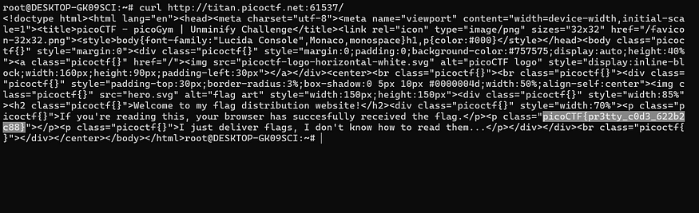

**Flag**

Flag - picoCTF{pr3tty\_c0d3\_622b2c88}